Bourton’s New Village Hall
Community Workshop in the Village Hall
Sat 15th September 2.00 to 5.00pm & 7.00 to 9.00pm
Everyone is invited to a Community Workshop in the Village Hall on Saturday 15th September. During the afternoon, there will be the opportunity to view and comment on proposals for housing, new village hall and additional amenity space on the two sites approved in the Neighbourhood Plan. Video footage will help convey a good sense of how a Hall will be set in each location. In the evening, there will be an independently chaired public discussion. The comments and balance of views at the workshop will be taken into account by the Parish Council whose task it will be to decide on a preferred site.
Bourton’s New Village Hall
Community Workshop in the Village Hall
Sat 15th September 2.00 to 5.00pm & 7.00 to 9.00pm
Everyone is invited to a Community Workshop in the Village Hall on Saturday 15th September. During the afternoon, there will be the opportunity to view and comment on proposals for housing, new village hall and additional amenity space on the two sites approved in the Neighbourhood Plan. Video footage will help convey a good sense of how a Hall will be set in each location. In the evening, there will be an independently chaired public discussion. The comments and balance of views at the workshop will be taken into account by the Parish Council whose task it will be to decide on a preferred site.

Please come and participate!

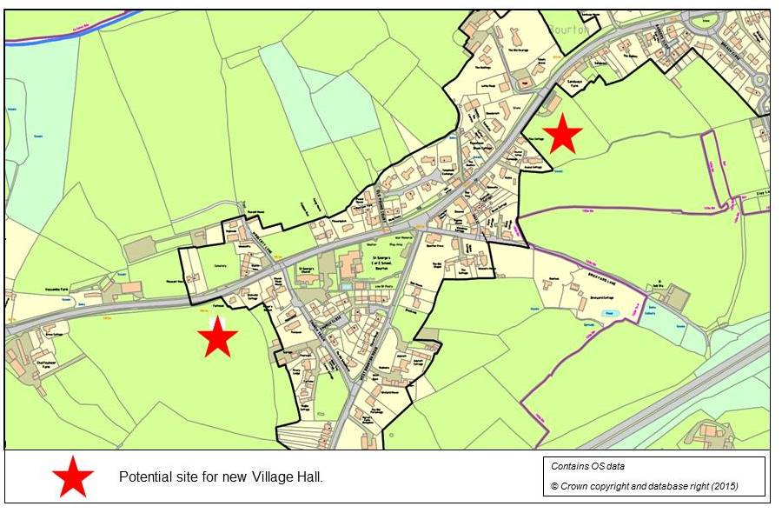

Please come and participate!

